So what’s the difference between Windows Server 2008 Foundation and other versions of Windows Server 2008?

Although the core features are the same, there are important differences between Windows Server 2008 Foundation and other editions of Windows Server 2008 that you should be aware of before you deploy Windows Server 2008 Foundation.

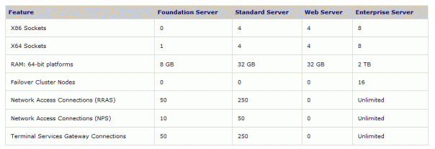

In addition, here are some considerations and limitations for Windows Server 2008 Foundation which clearly draw the line between it and regular versions of Windows Server 2008:

**Supported users** - Windows Server 2008 Foundation can be used to create up to 15 user accounts that can access and use the server software. Each user account permits one user, using any device, to access and use your server software.

**X86 CPUs** - Windows Server 2008 Foundation is available only as a 64-bit system, so you cannot use it on X86-only hardware.

**X64 CPUs** - Windows Server 2008 Foundation includes support for just one x64 CPU (CPU=socket).

**Random Access Memory (RAM)** - Windows Server 2008 Foundation provides access to a maximum of 8 GB of available memory.

**Failover cluster nodes** - A failover cluster node is a server that is a member of a failover cluster. A failover cluster node can own and run clustered services and applications. You cannot deploy Windows Server 2008 Foundation as a failover cluster node.

**Server Message Block connections** - Windows Server 2008 Foundation supports a maximum of 30 simultaneous inbound connections. This means that the total combined number of user accounts and devices that can connect to shares that are located on the server at any given time cannot exceed 30. Connection attempts that exceed the allowable 30 receive a message informing them that the server cannot accept any additional connections at that time.

**Network access connections (RRAS)** - The Routing and Remote Access service (RRAS) in Windows Server 2008 supports remote user or site-to-site connectivity by using virtual private networking (VPN) or dial-up connections. Windows Server 2008 Foundation supports a maximum of 50 RRAS connections.

**Network access connections (NPS, or RADIUS)** - NPS (or RADIUS) performs centralized connection authentication, authorization, and accounting for many types of network access, including wireless and virtual private network (VPN) connections. Windows Server 2008 Foundation supports a maximum of 10 NPS connections.

- A Terminal Services Gateway (TS Gateway) connection enables authorized remote users to connect to terminal servers and to remote desktops on the corporate network from any Internet-connected device that is running Remote Desktop Connection (RDC) 6.0. Windows Server 2008 Foundation supports a maximum of 50 TS Gateway connections.

**Virtual machine usage rights** - Windows Server 2008 Foundation is licensed to run only in a physical operating system environment.